Docker Interview question
- What is Docker and what are its main components?

--- Docker is an open-source containerization platform that enables developers to build, deploy, run, and manage applications inside containers—lightweight, standardized, isolated environments that package an application with all its dependencies, ensuring consistency across various computing environments.
Components
- Docker Engine: The program that starts and runs containers on your computer.
- Docker Images: Read-only templates containing app code and dependencies.
- Docker Containers: Isolated, running instances created from images.
- Docker Hub: An online place to find, download, or share images with others.
- Docker Compose: A helper that lets you start several app containers together using a single file for setup.
- Docker CLI & API: Command-line tools and an interface used to control and manage Docker and containers.

------------------------------------------------------------------------------------------------------------------------------------------------------------

2) How do containers differ from virtual machines?
A) Containers are like small boxes that hold just your app and what it needs to run, all sharing your computer’s main operating system to work. Because they share the system, they are light and start quickly.

B) Virtual machines (VMs) are like separate computers inside your computer. Each VM runs its own full operating system, so they are heavier, use more resources, and take longer to start.

In simple terms:
-- Containers share the main OS and are fast and small.
-- VMs have their own OS and act like complete separate computers, so they use more resources.
Containers are good for running lots of apps efficiently, while VMs are better when you need strong isolation or different operating systems.

3) What is the role of Docker Engine and Docker Hub?
1) The Docker Engine is the core part of Docker that builds, runs, and manages containers on your system. It acts like the engine that powers containerized applications, handling tasks such as starting and stopping containers and managing resources.
2) The Docker Hub is an online service where users can store, share, and download Docker images. It acts like a library or marketplace for ready-to-use container templates, making it easy to find and share application images.
In short:
Docker Engine runs and controls containers on your machine.
Docker Hub is a place to find and share container images with others.

4) What is the lifecycle of a Docker container?
1)-- Created: First, a container is made from a pre-built package called an image. At this stage, it is ready but not started yet.
2)-- Running: When you start the container, it begins working and doing its job (like running a web server or app).
3)-- Paused: You can temporarily freeze the container’s work, like pressing pause on a video, so it stops but is still there.
4)-- Unpaused: When you want the container to continue work after pausing, you unpause it to resume.
5)-- Stopped: You can stop the container so it finishes its tasks and shuts down safely.
6)-- Deleted: Finally, when you don’t need the container anymore, you remove it from your system, freeing up resources.
5) How do you create, start, stop, and remove containers using Docker CLI?

1) Create -- docker container create --name mynginx nginx Create Nginx container (not started)
2) Start --docker container start mynginx Start the created container
3) Stop --docker container stop mynginx Stop the running container
4) Remove --docker container rm mynginx Remove the stopped container

6) Explain Dockerfile best practices for production builds.
-- Use multi-stage builds to keep the final image small and clean by separating build and runtime stages.
--Choose small and trusted base images (like Alpine) to reduce size and security risks.
--Combine commands to reduce the number of image layers for faster builds and smaller images.
--Avoid running containers as root user; create and use a non-root user.
--Do not store secrets like passwords or API keys inside the Docker file.
--Pin exact versions of base images to ensure consistent builds.
--Use a .dockerignore file to exclude unnecessary files from the build.
--Add healthchecks to monitor if the container is working properly.
--Regularly update and scan images to fix security issues.
7) Describe the difference between Docker run and Docker start commands.
>> docker run creates a new container from a specified image and then starts it. It's like launching a brand-new container and setting it up with options like ports, volumes, and environment variables. Use this when you want to create and run a container for the first time or with new configurations.
>> docker start only starts an existing container that was previously stopped. It does not create a new container but resumes the old one with its current state, files, and settings intact. Use this when restarting a container you stopped earlier.
8) How do you use Docker Compose for multi-container setups?

Troubleshooting and Optimization
-------------------------------------------------------------------------------------------------------------------

8) How do you debug a failed container? Which commands do you use?

- Check all containers: docker ps -a
- View container logs (for errors): docker logs <container>
- Follow live logs: docker logs -f <container>
- Get detailed info: docker inspect <container>
- Run a shell inside container: docker exec -it <container> sh
- Commit failed container and run interactively for exploration:

What is Docker Content Trust (DCT) and how does it secure deployment?
Docker Content Trust is a security feature in Docker that checks if container images were signed by the publisher. It uses digital signatures so only trusted images are allowed.
When turned on (DOCKER_CONTENT_TRUST=1), Docker blocks images that aren’t signed.
Images are checked by Docker using special keys to confirm the source and make sure nothing has changed.
This helps protect systems from unsafe or tampered images, making deployments safer.
In short:
Docker Content Trust makes sure the container images are published by who they say and haven’t been changed, keeping deployments safe and reliable.
--------------------------------------------------------------------------------------------------------------------------------------
How does Docker achieve container isolation? Explain roles of namespaces and cgroups.
Docker isolates containers using two main Linux features:
Namespaces give each container its own private view of system resources like processes, network, and files, so containers don’t see or interfere with each other.
Cgroups limit how much CPU, memory, and other resources a container can use, preventing any one container from using too much and affecting others.
Together, namespaces keep containers separated, and cgroups control their resource use to ensure safe and efficient container operation.
--------------------------------------------------------------------------------------------------------------------------------------
How would you troubleshoot containers consuming excessive memory?
To troubleshoot containers consuming excessive memory, follow these concise steps with commands:
Monitor Memory Usage:
1) docker stats <container_id> This shows real-time memory and CPU usage.

docker logs <container_id> Analyze logs for memory-related errors or leaks.

docker inspect <container_id> --format='{{.HostConfig.Memory}}' Validate if resource limits are correctly configured to prevent overuse.

docker restart <container_id> Sometimes, restarting the container helps clear memory.

DevOps and CI/CD Integration
---------------------------------------------------------------------------------------------------------------------------------------------
How do you implement Docker in a CI/CD pipeline?
- Create a Dockerfile:
Write instructions in a file called Dockerfile that tells Docker how to build your app’s container image.
- Build the Docker Image:
When you make changes to your code, the CI system (like Jenkins or GitHub Actions) automatically runs:
docker build -t your-app-name .
This creates a container image of your app.
- Test the Container:
The CI system runs your tests inside the container to make sure everything works:
docker run your-app-name run-tests
- Push the Image to Registry:
After tests pass, the image is uploaded to a container registry (like Docker Hub) so it can be stored and shared:
docker push your-dockerhub-username/your-app-name
- Deploy the Container:
Finally, the container is deployed to a server or cloud platform by pulling the image from the registry and running it there.
This process automates building, testing, and deploying your app inside Docker containers, making deployments consistent and easy to manage.

Which monitoring tools do you use for live Docker metrics and logs?
Prometheus & Grafana:
Prometheus collects and stores container metrics, while Grafana visualizes them with customizable dashboards.

How do you manage secrets securely when deploying Docker containers?
Environment Variables (with Caution):
Pass secrets as environment variables but avoid hardcoding them in Dockerfiles or version control.
Use CI/CD tools to inject them at runtime securely.
--------------------------------------------------------------------------------------------------------------------------------------
How would you migrate a Docker container to another host?

To migrate a Docker container to another host, follow these simple steps:
Commit the running container to an image:
bash
docker commit <container_id> <new_image_name>
Save the image to a tar file:
bash
docker save -o <image_name>.tar <new_image_name>
Copy the tar file to the new host:
Use scp or any file transfer method:
bash
scp <image_name>.tar user@new-host:/path/
Load the image on the new host:
bash
docker load -i /path/<image_name>.tar
Run the container on the new host:
bash
docker run -d --name <container_name> <new_image_name>
--------------------------------------------------------------------------------------------------------------------------------------
What approach do you take for scaling applications during peak usage?
To handle peak usage and scale applications simply:
- Add More Instances:
Run more copies of your app so the load is shared (called horizontal scaling).
- Automatic Scaling:
Use tools that automatically add or remove instances based on traffic or resource use (auto-scaling).
- Use Load Balancers:
Distribute user requests evenly to all running instances so no single one gets overloaded.
- Cache Data:
Store frequently used data temporarily to reduce work on databases and speed up responses.
- Make Sure Resources Are Enough:
Allocate enough CPU and memory for each app instance to run smoothly.
- Scale Databases:
Make your database handle more requests by adding copies or upgrading its capacity.
This way, the app stays fast and reliable even when lots of users visit at once.
--------------------------------------------------------------------------------------------------------------------------------------------

How would you resolve a container failing to start due to missing dependencies?

To fix a container failing to start due to missing dependencies:
- Check logs with
docker logs <container_id>
to find missing dependencies.
- Update the Dockerfile to install needed dependencies.
- Rebuild the image using
docker build -t <image_name> .
- Run the container again to verify it starts.
- Ensure any required files or volumes are properly mounted.
This ensures the container has everything it needs to run.

Port Number | Protocol | Service | Usage
22 | TCP | SSH (Secure Shell) | Remote server/CI host access
80 | TCP | HTTP | Web server, App deployment
443 | TCP | HTTPS | Secure web traffic
21, 20 | TCP | FTP/FTP-Data | File transfers
23 | TCP | Telnet | Insecure remote shell (rare)
3389 | TCP | RDP | Windows Remote Desktop
3306 | TCP | MySQL | Database connection
5432 | TCP | PostgreSQL | Database connection
8080 | TCP | HTTP (Alternate/Proxy) | Web apps, Tomcat/Jetty
53 | TCP/UDP | DNS | Domain name resolution
25 | TCP | SMTP | Email sending
110, 143 | TCP | POP3, IMAP | Email retrieval
445 | TCP | SMB | File sharing (Windows)
5900 | TCP | VNC | Virtual Network Computing
514 | UDP | Syslog | Log collection
161 | UDP | SNMP | Network management

What is a multi-stage build in Docker and why is it a best practice?
A multi-stage build allows multiple FROM instructions in a Docker file, where each FROM introduces a new build stage.
This method produces a smaller and cleaner image that has only what is needed to run the application, not the tools used to build it.
This helps make the image faster to download, uses less storage, and is more secure because it has less unnecessary stuff that could be a security risk.
So, multi-stage builds help developers make efficient, lightweight, and safer Docker images in a simple way by using just one Docker file.

How does a multi-stage build reduce the final image size?
This makes the final image much smaller, faster to use, and more secure by removing unnecessary build tools and files.

How do multi-stage builds improve security?
Multi-stage builds improve security by removing build tools from the final image, leaving only what’s needed to run the app. This reduces vulnerabilities and makes it harder for attackers to exploit the container.

Simple multistage Docker file

Form node:18-alpine As installer
WORKDIR /app
COPY package*.json ./
RUN npm install
COPY . .
RUN npm run build
FROM nginx:latest AS deployer
COPY --from=installer /app/build /usr/share/nginx/html/

What is Trivy
Trivy is an open-source vulnerability scanner for container images, file systems, and Git repositories.
It detects vulnerabilities, misconfigurations, and provides severity levels with remediation suggestions.
How does Trivy scan container images?
Trivy is a simple, free tool that helps find security problems in software packages inside container images, files, or code repositories. It quickly checks for known security issues and mistakes, showing how serious each one is and suggesting ways to fix them. This helps developers keep their software safe before using or sharing it.
Example :
trivy image --format table -o trivy_report.html nameisvikas/javaproject

What is Docker Compose and how does it work?
Docker Compose is a tool that defines and runs multi-container applications using a YAML file, describing services, networks, and volumes needed for the application.
What are the main sections in a docker-compose.yml file?
Key sections include version, services, networks, and volumes. The services section specifies individual containers, their dependencies, environment variables, and port mappings.
How does Docker Compose simplify multi-container app development?
It allows spinning up all related containers and services with a single command (docker-compose up), automates dependency resolution, and ensures consistent environments for testing and deployment.
Can Docker Compose be used with JSON files, or is YAML mandatory?
Yes, JSON can be used. Compose will accept a .json file if specified
How does Docker Compose handle networking between containers?
By default, all services within a Compose file share a network, and can communicate using the service names as DNS entries.
What is the difference between docker-compose up and docker-compose down?
up starts all defined services and builds images as needed; down stops and removes all containers, networks, and optionally images and volumes
How is Docker Compose used in CI/CD pipelines?
It's often used to define test environments where multiple dependent services are spun up to run automated tests, ensuring application consistency across build and deploy stages.
How to structure a multi-service docker-compose.yml file?
Define each service under the services: block, setting appropriate images or build context, ports, environment variables, volumes, and network parameters.

Docker values usually mean:
- Environment Variables: Simple key=value settings you give to containers to configure apps without changing the image. For example, setting a database password or app mode.
- Volumes: Storage areas where containers keep files that persist even if the container stops or is removed. Useful for saving data like databases.
In short, environment variables control how containers behave at runtime, and volumes keep your important data safe across container restarts. Both help make Docker flexible and reliable.

-------------------------------------------------------------------------------------------------------------------------------------

Docker compose file writing

A Docker Compose file uses YAML syntax to define and run multi-container Docker applications. Here is a simple example with essential syntax and explanations for beginners.
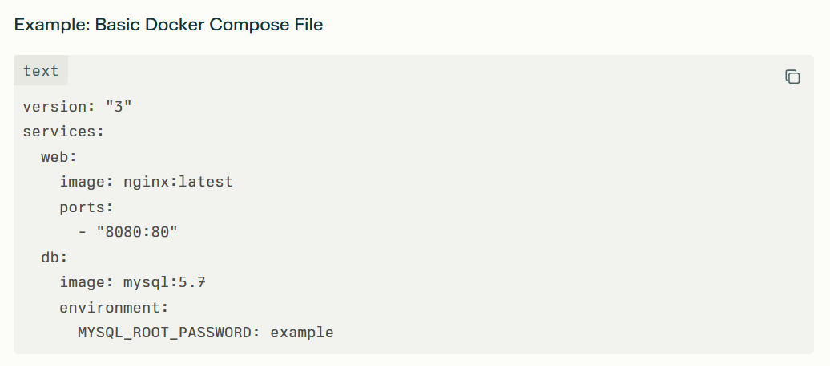

- version: "3"

In a Docker Compose file, version: "3" sets the format version for the compose file. This tells Docker Compose which features and syntax the file can use, and helps make sure your setup is compatible with your Docker installation.
For example, Compose file version 3 is optimized for using Docker Swarm and includes features that may not be available in earlier versions. While recent versions of Docker Compose may ignore the version line, it's good practice to include it for backward compatibility, especially if you are following tutorials or working with older setups

- Services
The services: section in a Docker Compose file is where each part of an application is defined as a separate service. Each service runs in its own container and is individually configured, for example as a web server, database, or cache.
Every service under services: is essentially a container with its own specific role in the application stack.
This section lets you specify the Docker image to use, environment variables, network settings, and volumes for each service, providing full control and flexibility for multi-container applications.
Services can communicate with each other using service names as hostnames, making it easy to connect components like a web server to a database.
In summary, the services: section organizes and manages all the containers needed for an application, ensuring they can operate together efficiently.

- Web :

In a Docker Compose file, the line web: defines the name of a service (container) within the services section. This is just a label or identifier and can be anything meaningful such as web, db, api, etc.
The name helps to reference the service within the Compose file and when using Docker commands, like checking logs or networking between services.
For example, in networking, other services can reach the container running this service using the name web as a hostname.
The service name does not affect the actual container name unless you explicitly set the container name property.
Choosing clear service names makes it easier to manage and understand multi-container applications.

- image: nginx:latest

The line image: nginx:latest in a Docker Compose file tells Docker to use the official Nginx image from Docker Hub to create the container. Here’s what it means for beginners:
image: specifies which pre-built Docker image to use for the container.
nginx is the name of the image for the popular web server.
latest refers to the most recent stable version of this image available on Docker Hub.
When you run Docker Compose, it will check if this image is available locally, and if not, it will download (pull) it from Docker Hub automatically.
Using the latest tag means you always get the latest version, but you can specify specific versions by changing the tag (e.g., nginx:1.23).
This lets you quickly spin up a ready-to-use Nginx web server container without building or configuring it yourself.

- ports:
In Docker Compose, the ports: section maps network ports between your computer (the host) and the running container.
The line "8080:80" means that port 8080 on your host machine is connected to port 80 inside the container.
Port 80 is the default port where the Nginx web server listens inside the container.
So, when you open a browser and visit localhost:8080, your request is forwarded to port 80 in the container, showing the Nginx welcome page running inside the container.
This mapping allows access to container services through custom ports on your host, enabling multiple services or containers to avoid port conflicts on the host.
Thus, port mapping is essential for exposing containerized applications to your local machine or external network.

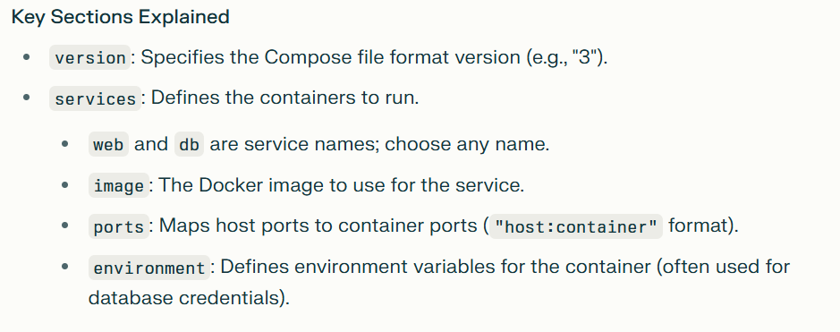

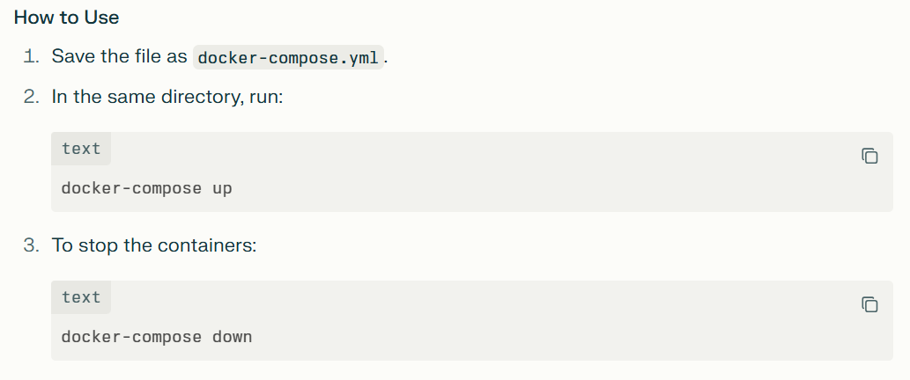

- What is Docker Compose and what is its primary use?
Docker Compose is a tool for defining and running multi-container Docker applications using a YAML file. It simplifies managing multiple containers by allowing configuration in a single file and running them with one command.

- How does Docker Compose help in managing multi-container Docker applications?
It lets you define all services, networks, and volumes in a single file, making it easy to start, stop, and configure multiple containers as a group.

- Explain the structure of a Docker Compose file.
The file is written in YAML format and includes sections like version, services (for container definitions), volumes (for data persistence), and networks (for container communication).
- What does the version field in a Docker Compose file signify?
It specifies the Compose file format version, which determines the available features and syntax compatibility with Docker Compose.

- How do you define and link multiple services in a Docker Compose file?
You list services under the services: section, each with its own configuration. Services can communicate by referencing other service names as hostnames.

- How do you perform port mapping in Docker Compose?
Using the ports: section, you specify host-to-container port mappings such as "8080:80", allowing access to container services via host ports.

- How can you specify environment variables in a Docker Compose file?
Use the environment: section under a service to define key-value pairs for variables inside the container.

- Can you define dependencies between services in Docker Compose? How?
Yes, with depends_on: you specify the order of service startup but it doesn’t wait for service readiness—only container start.

- What is the purpose of the networks section in Docker Compose?
It defines custom networks for services to communicate securely and isolate container traffic.

- How would you scale services using Docker Compose?
Use docker-compose up --scale servicename=num to run multiple instances of a service.

- How can you override settings defined in the docker-compose.yml file?
You can use multiple Compose files (e.g., docker-compose.override.yml) to override or add configuration selectively.

12 ) How can you use Docker Compose in a CI/CD pipeline?
Use Compose files to define test or deployment environments, then automate running containers for integration tests or app deployment in CI/CD workflows
Dockerfile to build MySQL database image:
FROM mysql:latest
ENV MYSQL_ROOT_PASSWORD=password
ENV MYSQL_DATABASE=mydb
ENV MYSQL_USER=user
ENV MYSQL_PASSWORD=userpassword
EXPOSE 3306

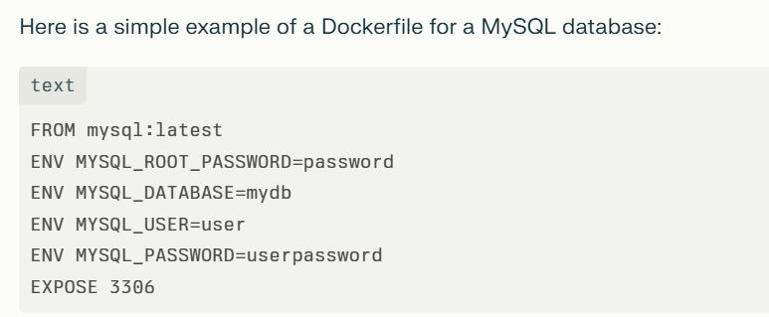

These commands are environment variable settings used to configure a MySQL database container in Docker:
ENV MYSQL_ROOT_PASSWORD=password: Sets the root user password for the MySQL server to "password". This is mandatory for the official MySQL image and secures the root account.
ENV MYSQL_DATABASE=mydb: Creates a new database named "mydb" automatically when the container starts for the first time.
ENV MYSQL_USER=user: Creates a new MySQL user account with the username "user" when the container initializes.
ENV MYSQL_PASSWORD=userpassword: Sets the password for the user account "user" created by the above variable.

To establish a connection between two Docker containers for hosting a two-tier application (e.g., web server and database), the best practice is to place both containers on the same Docker network. This allows the containers to communicate by referring to each other by container or service name.

In two ways ,we can establish the connection between multiple docker

- Using Docker user-defined bridge network:
Create a network:
docker network create my_network
Run containers on that network:
docker run -d --network my_network --name db_container mysql
docker run -d --network my_network --name web_container my-web-app
The web container can connect to the database using the hostname "db_container" on the relevant port.
2) Using Docker Compose for multi-container apps:

- Define services in a docker-compose.yml file.

- Docker Compose automatically creates a network and connects all services to it.
- Containers communicate using service names as hostnames.

Example minimal docker-compose.yml for two-tier app:

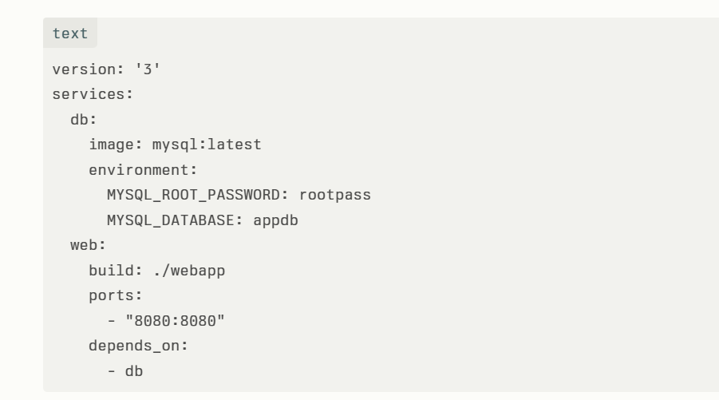

Explanation for few commands

- build: ./webapp

The build: ./webapp command in a Docker Compose file tells Docker Compose to build a Docker image for the service using the Dockerfile located in the ./webapp directory.
:
Here's what it means in detail
build specifies the context (folder) to use for the Docker build.
./webapp is a relative path to the folder containing the Dockerfile and source files needed to create the image for this service.
When you run docker-compose up or docker-compose build, Docker will look into the ./webapp directory, find the Dockerfile there, and use it to build a Docker image.
This image will then be used to create a container for that service.
In short, this command automates building a custom image for your service based on the Dockerfile and files in the specified path before running the container.

- depends_on

The depends_on key in a Docker Compose file specifies service dependencies and controls the order in which containers are started and stopped.
depends_on: - db means the service depends on the db service (usually a database).
Docker Compose will start the db service before starting the service that declares the dependency.
It ensures that the dependent service won't start until the services it depends on are at least started.

